Bài tập chương 3

Bài 3.1: Thực hiện các phép toán

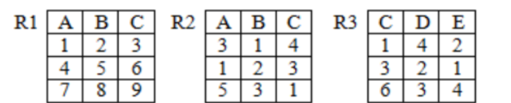



|  |  |  |
| --- | --- | --- |
| A | B | C |
| 1 | 2 | 3 |
| 4 | 5 | 6 |
| 7 | 8 | 9 |
| 3 | 1 | 4 |
| 5 | 3 | 1 |



|  |  |  |
| --- | --- | --- |
| A | B | C |
| 1 | 2 | 3 |



|  |  |  |
| --- | --- | --- |
| A | B | C |
| 4 | 5 | 6 |
| 7 | 8 | 9 |



|  |  |  |
| --- | --- | --- |
| A | B | C |
| 3 | 1 | 4 |
| 5 | 1 | 3 |



|  |  |  |  |  |  |
| --- | --- | --- | --- | --- | --- |
| A | B | C | C | D | E |
| 1 | 2 | 3 | 1 | 4 | 2 |
| 1 | 2 | 3 | 3 | 2 | 1 |
| 1 | 2 | 3 | 6 | 3 | 4 |
| 4 | 5 | 6 | 1 | 4 | 2 |
| 4 | 5 | 6 | 3 | 2 | 1 |
| 4 | 5 | 6 | 6 | 3 | 4 |
| 7 | 8 | 9 | 1 | 4 | 2 |
| 7 | 8 | 9 | 3 | 2 | 1 |
| 7 | 8 | 9 | 6 | 3 | 4 |



|  |  |  |  |  |
| --- | --- | --- | --- | --- |
| A | B | C | D | E |
| 1 | 2 | 3 | 2 | 1 |
| 4 | 5 | 6 | 3 | 4 |

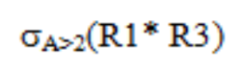

|  |  |  |  |  |
| --- | --- | --- | --- | --- |
| A | B | C | D | E |
| 4 | 5 | 6 | 3 | 4 |



|  |  |  |  |
| --- | --- | --- | --- |
| B | C | D | E |
| 2 | 3 | 2 | 1 |
| 3 | 1 | 4 | 2 |



|  |  |  |
| --- | --- | --- |
| A | C | D |
| 1 | 3 | 2 |
| 4 | 6 | 3 |



|  |  |  |
| --- | --- | --- |
| B | C | D |
| 3 | 1 | 4 |

Ôn phép toán quan hệ

1. Đưa ra danh sách các mặt hàng màu đỏ (P)

|  |  |  |  |  |
| --- | --- | --- | --- | --- |
| P# | Pname | Color | Weight | City |
| P1 | Nut | Red | 12 | LonDon |
| P4 | Screw | Red | 14 | LonDon |

1. Đưa ra mã của các hãng cung ứng mặt hàng P1 hoặc P2

* Ta tìm mã của hãng cung ứng mặt hàng P1: